Department of Computer Engineering
Object Oriented Programming

Final Project Report
Submitted by:

Name: Tahir Noor
Reg. no: 2025-CYS-170
Cyber Security
Sec-C (FALL-25)
Morning
2nd Semester

Submitted to:
Hafiz Muhammad Mubashar

Session: 25-29


University of Engineering and Technology, Lahore

Project Title

Departmental Store Billing System Report

2. Introduction

The Departmental Store Billing System is a Java-based console application developed to manage the billing process of a departmental store. The system allows Admin and Cashier users to perform billing operations such as adding items, managing customer details, applying discount, adding tax, selecting payment method, and generating a final bill.
This project is designed by using important Object-Oriented Programming concepts. The system divides the complete billing process into different objects and modules. Each object has its own responsibility, which makes the program more organized, readable, and easier to maintain.

3. Objectives of the Project

To create a simple billing system for a departmental store.
To apply Object-Oriented Programming concepts in a real-world project.
To manage item details in an organized way.
To manage customer information during billing.
To calculate subtotal, discount, tax, and final bill amount.
To provide separate access for Admin and Cashier.
To save item and bill information using separate data access classes.
To make the project easy to understand, maintain, and improve.

4. Scope of the Project

This system is useful for small departmental stores where billing needs to be handled in a simple and systematic way. It helps the user manage customer billing, item details, payment method, and final receipt generation.
The current system is console-based, but it can be improved in the future by adding a graphical interface, complete database system, inventory management, and sales reports.

5. Main Features of the System
5.1 Admin Login
The Admin has more control over the system. Admin can perform normal billing operations and can also update item price and quantity before finalizing the bill.
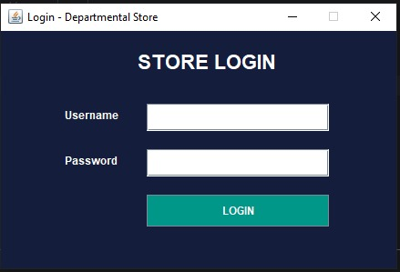

5.2 Cashier Login
The Cashier can perform normal billing tasks such as adding items, viewing items, applying discount, adding tax, selecting payment method, and finalizing the bill.
5.3 Customer Details
The system collects customer name and phone number before billing. This information is displayed on the final receipt.
5.4 Item Management
The system allows the user to add item name, price, and quantity. Every item has its own subtotal, which is calculated according to price and quantity.
5.5 Discount and Tax
The system allows discount and tax to be applied to the bill. This makes the billing process more realistic and practical.
5.6 Payment Method
The system provides different payment options such as JazzCash, Easypaisa, Bank Transfer, and Cash.

5.7 Final Receipt
The system generates a final receipt that includes customer details, item details, subtotal, discount, tax, grand total, payment method, and date/time.
5.8 Bill Saving
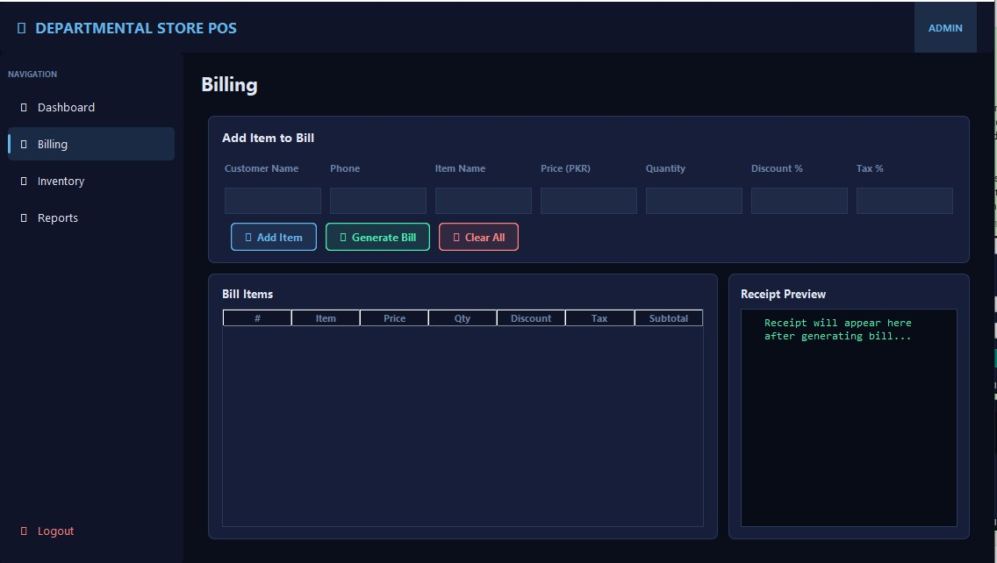
The system saves bill information using a separate data access class. This shows that the project is structured in a modular way.
Object-Oriented Programming Concepts Used

The project follows important Object-Oriented Programming concepts. These concepts help make the system organized, reusable, and easy to maintain.

### 6.1 Class and Object

* A class is used to define the structure of an item in the system.
* The Item class stores product information such as name, price, quantity, and subtotal.
* Whenever a product is added to the cart, an object of the Item class is created.
* Each object represents one separate product in the bill.
* This helps the system manage every item individually.

### 6.2 Encapsulation

* Encapsulation means keeping data and related operations together.
* In this project, item data and item-related actions are placed in the Item class.
* The item name, price, quantity, and subtotal are managed in one place.
* The system can update item price and quantity through item-related methods.
* This makes the program more organized and easier to update.
### 6.3 Abstraction

* Abstraction means hiding internal working and showing only necessary details to the user.
* In this project, the user only selects options such as Add Item, Apply Discount, Add Tax, Payment Method, and Finalize Bill.
* The user does not need to understand how the system calculates subtotal, discount, tax, and grand total.
* The calculation process works internally, and the user only sees the final result on the receipt.
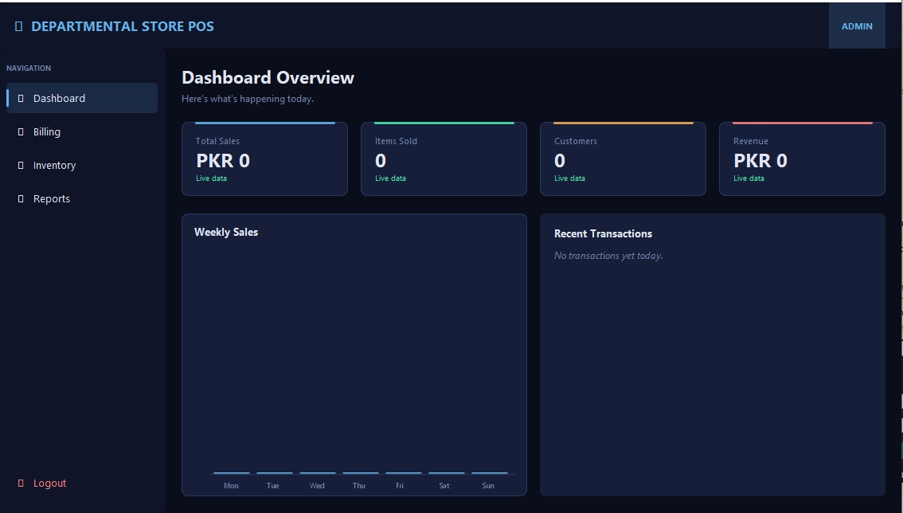
* This makes the system simple and user-friendly.

### 6.4 Inheritance

* Inheritance means creating child classes from a parent class.
* In the current project, inheritance is not directly used.
* However, the system has two user roles: Admin and Cashier.
* In future improvement, a parent User class can be created, and Admin and Cashier can be made child classes.
* This would make the role system more properly object-oriented.

### 6.5 Polymorphism

* Polymorphism means one action can perform different tasks in different situations.
* In the current project, polymorphism is not directly implemented.
* However, it can be added in the payment system.
* For example, Cash Payment, JazzCash Payment, Easypaisa Payment, and Bank Transfer can have separate payment processing methods.
* This would make the payment system more flexible and object-oriented.

## 7. Conclusion

The Departmental Store Billing System is a simple Java project that uses Object-Oriented Programming concepts to manage store billing. The project mainly uses class, object, encapsulation, and abstraction. Inheritance and polymorphism are not directly implemented, but they can be added in future improvements.

Overall, this project shows how OOP can be applied to a real-world billing system. It makes the system easier to understand, manage, and improve.

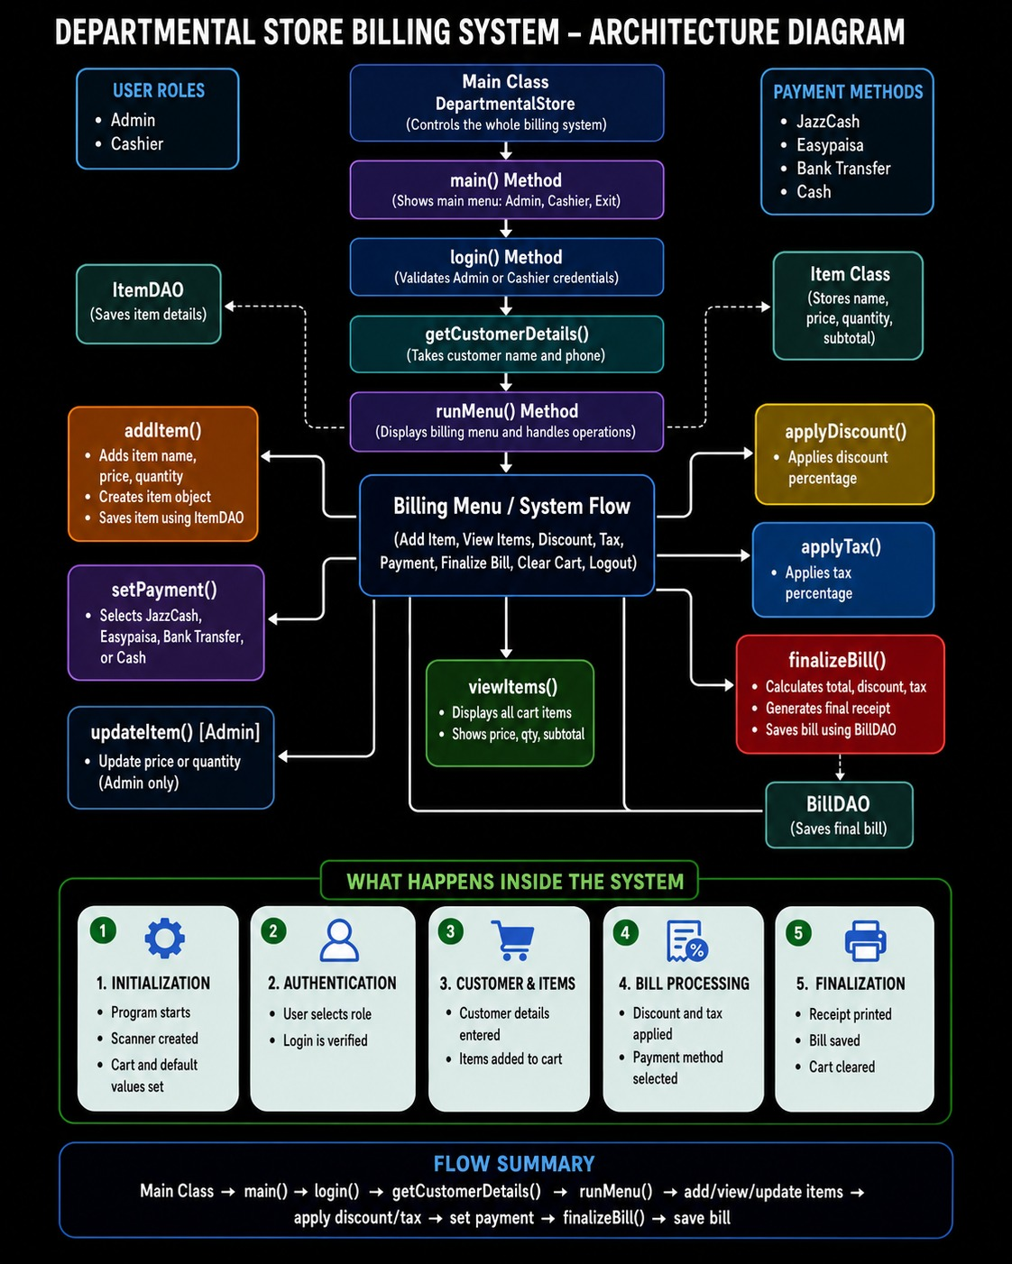
Architecture Diagram

